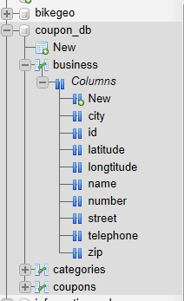

Coupon_db

Business

Id, name, street, number, city, zip, telephone, latitude, longtitude

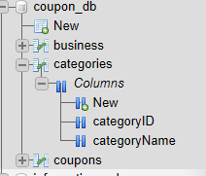

Coupon_db

Categories

categoryID, categoryName

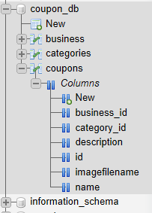

Coupon_db

Coupons

Id, business_id, category_id, name, description, imagefilename